Design Proposal

# Project Proposal

* **Project Description** [2.5 pts]:

My term project name is Bomb it. Player needs to defeat enemies by placing bombs to win the game.

* **Competitive Analysis** [2.5 pts]:

This game is not just a maze game, player can modify the maze by placing the bombs and create their own path. Players can have better freedom in this game.

Players can place bombs on the way NPCs pass by, or surround NPCs with bombs to kill NPCs to win the game.

Players will lose the game if they are bombed twice by npc‘s bombs or their own bombs.

**Structural Plan** [2.5 pts]:

Putting features like Generate the maze, Making characters can move around,Can successfully placing bombs and bombs can explode,Make the game visualized in different files and have a main file to call these functions.

**Algorithmic Plan** [2.5 pts]:

To automatically generate random mazes, using DFS.

And pathfinding for an opponent, use Dijkstra. To make sure the NPC can move around in the maze and they can create the path and place bombs.

* **Timeline Plan** [2.5 pts]:

04/16 generate maze and characters can move

04/18 player can put bomb and bomb can explode

04/20 pathfinding for an opponent

04/20-04/27 add more features in game

* **Version Control Plan** [1.5 pts]: A short description **and image** demonstrating how you are using version control to back up your code. Notes:

I sent my code by email to myself

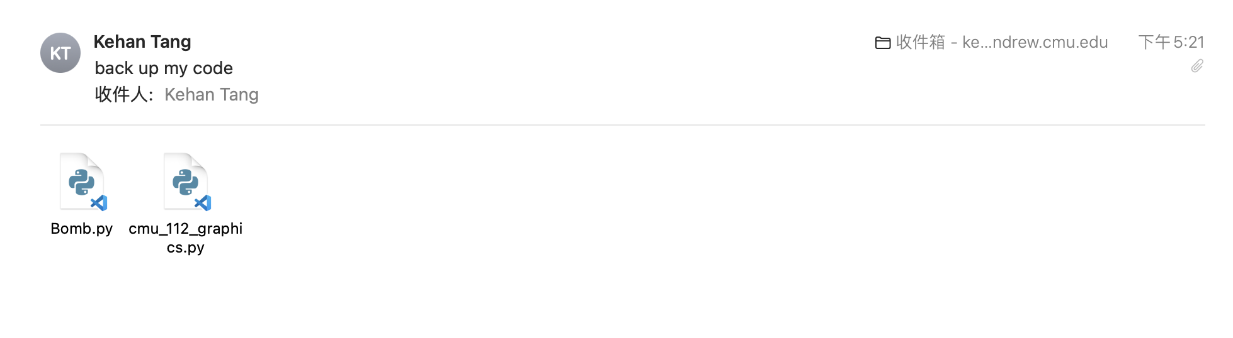

* **Module List** [1 pts]:

Don’t use any module

**· Storyboard**

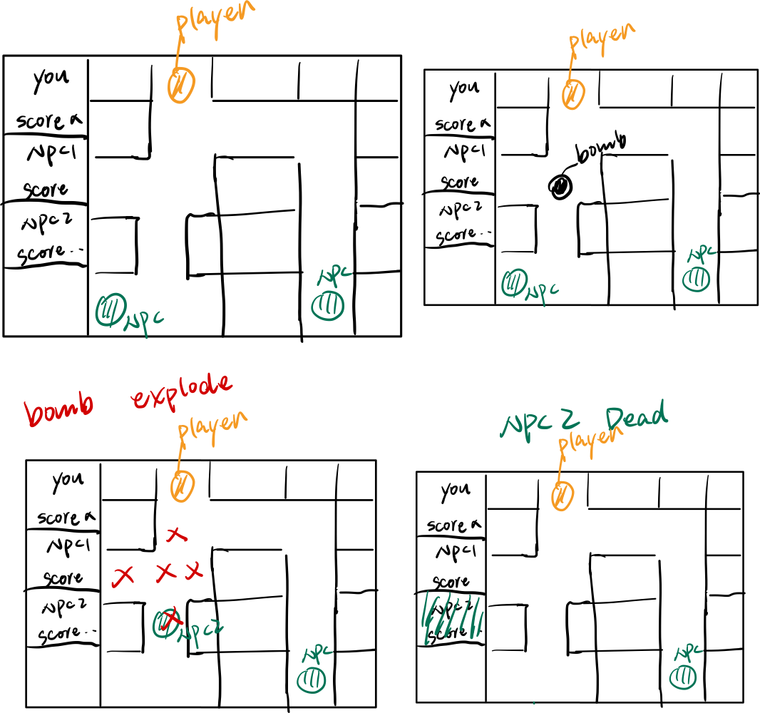

 'TP2 Update'

No changes made

 'TP3 Update'

Update the Algorithmic Plan, Since I have rewritten my maze generation part, I found it’s better to just use one time dfs. And Astar is not suitable for my enemy, it can’t find the shortest way. Instead, I use the Dijkstra.